# Fabio annicchiarico IBCM project: Allianz



INTRODUCTION

What are the risks an insurance company has to face during its existence? Essentially, we can categorize these risks in some families – Interest-related risks, credit risks are two of the most important ones, but overall these risks have to be estimated.

The instrument an insurance company has to estimate is to describe a model; the more a model is similar to what happen in the reality, the better it is. But these models has to follow the rules the EIOPA, the European regulation authority for insurance companies and pension schemes, has given them; in this way, they also comply with the incessant law.

In order to have an idea how insurance sector works and goes by, every year the regulation authority apply a model in order to create a comparison with the other institutions. The data we will use in this analysis are 2021 estimations. In particular, EIOPA modelled a portfolio, denominated in euro, taking into account 20 participants from 7 European states, with those following objectives: comparing model outputs by realizing a consistent asset risk profile that could assess risk levels in the sector; highlighting the causes of the presumed dispersion in the risk charges by analysing additional information such as individual risk charges, given asset classes.

Market and credit risks are composed by other classifications of risks – market risk incorporates the interest rate risk, equity risk, property risk, currency risk; the credit one incorporates default, migration and spread risks. Anyway, these risks will be analysed later.

These risks are modelled by insurance enterprises by using models, as we said before; there are two different approach to modelling, which are the modular approach and the integrate one. The first consider only the risk category it is expected to minimize, so that the others are not put considered. The integrate approach put in the same model all the risks and minimize everyone simultaneously. Given 20 participants, 12 use the integrated approach, the others use the other one, 2 of whom include the pure credit spread risk in the credit risk module and one, which models all the three components separately.

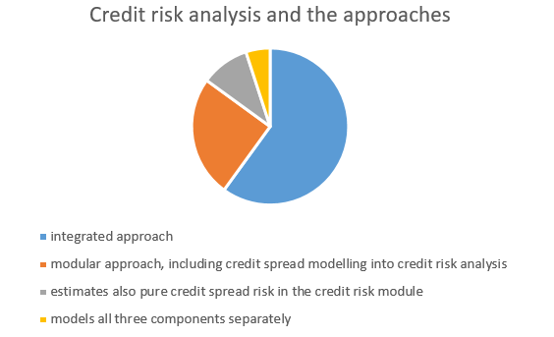

THE SHOCK MODELS

What is a shock? Shock represents a tail event of the underlying (marginal) risk factor distribution and considers a one-year time horizon). The volatility adjustment (VA) is not considered for every single insurance company since only 9 participants use VA in order to anticipate possible spread that could occur, meanwhile three others use it, but only keeping it constant in the simulations. The latter 8 participants do not use this tool.

SOME ISTITUTIONAL-BASED INFORMATIONS ABOUT INTERNAL MODELS

In order to comply the law, the supervisor has to verify its compliance with the law if major changes or sums of minor changes has been made to the internal model for impacts about the SCR (solvency capital requirement) or about the system of governance of the insurance company, or undertaking’s compliance with the requirements to use the internal model, or about the specifications required by the internal model, or about the risk profile of the insurance company. (chap 2 guidelines 6-7-8).

Overall, the supervisor is willing to incentive and improve the quality of those models since, from those, it is expected to define strategies and possible changes in decision-making processes (chap 3, guideline 11).

When a change because of the improvement of the internal model comes out and the supervisory body has also approved that, the insurance company should prove the compliance into taking into consideration different component of the use test, and the different uses of their system of governance, and eventually demonstrate that the time from the identification of a possible change to the relative implementation is appropriate (chap 3, guideline 12). With the aim to understanding the internal model, every single approach coming from administrative, management, supervisory body and relevant users should be taken into account, and authorities could consider interviewing that actually run the insurance undertaking, proving also that the internal model is used for decision-making (guidelines 13-14).

The insurance company should calibrate the internal model. In some situations, approximations are essential since it could not be done in a different way, or some data are not available. Insurance undertaking should challenge and justify the reliability of the output of these approximations over time and accordingly with the risk profile they have estimated. In case of recalibration, it is expected that the insurance undertaking should prove that the assumptions underlying the formula for the calculation of the SCR is valid under extreme losses conditions.

Also, if they choose to use an underlying variable for the calculation of the SCR, they also have to prove that are able to reconcile the difference between the basic own funds and the underlying variable in t=0, and the underlying variable in any situation up to and including t=1, especially under losses conditions, according to the undertaking risk profile. (guidelines 28-29)

The implementation of those models, as we wrote before, is subject to a validation policy. the insurance undertaking specifies processes and methods in order to validate the internal model and their purposes, the regular frequency and hypotheses of circumstances which could trigger other validations, and people who are responsible for that and the procedure that the insurance undertaking should follow in order to sort out any problems for maintaining the reliability of the decision-making process (guideline 32).

Any scopes and purposes should be explained and extensively described, for each part of the internal model, and into the appropriateness of the calculations in order to ensure that the regulatory capital will not be expressed wrongly. (guideline 33)

If there are any limitations that could affect the validation process, the insurance undertaking should document these limitations and issue a statement which he declares which are the circumstances under which the validation is ineffective. (guideline 35).

The responsible for the validation process belongs to the risk-management function. The insurance undertakings should ensure this function actively fulfils its responsibilities. (guideline 37).

Everything about the internal model and its limitations, who is the responsible for and which methodologies has been actively used in order to produce the underlying data must be written down in a detailed document (that complies with the article 243 (3) of Commission Delegated Regulation 2015/15), that includes stress tests, the appropriateness of the documentation, the user manuals and processes descriptions, and documentations about software that has been used during the process (guidelines 40 up to 49).

THE BENCHMARK PORTFOLIO SETUP FOR MARKET AND CREDIT RISKS

The benchmark portfolio setup has three different perspectives:

* the asset-BMPs, which put a stress on the ‘’linear combinations of various fixed income, equity and real estate instruments’’, and is chosen in relation to real asset allocations of the insurance sector in the respective market. EIOPA, for this BMP, take into account 7 countries that are Belgium, Germany, Spain, France, Ireland, Italy, and Holland. EIOPA also use it to determine the Volatility Adjustment.
* The Liability-BMPs, which cover the possible classes of liabilities. In particular, EIOPA take in exam the risk-free zero coupon bond, even though they consider it to be too simplifying because they do not capture asset-liability interactions. In particular, this BMP reflect 2 positions: the short and the long ones, for two different cash flows profiles for the undertakings. The long position has a negative duration mismatch since it holds a higher weighted average duration on the liability side compared to the fixed income assets; the short position has a positive duration mismatch since it holds a lower weighted duration on the liability side compared to the fixed income assets.
* The asset liability-BMPs represent the combination of the latter. Two liabilities are taken and scaled in such a way the net asset value of those asset liabilities BMPs reflect the average ‘’NAV to total assets’’ ratio across all European insurance undertakings (13% circa).

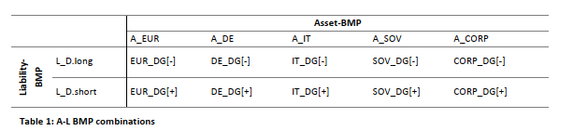

About the latter point, EIOPA has took into account this categorization in order to describe the VA and how this VA works. Using a box-and-whiskers plot, which take into exam the 1st and 3rd quartiles, with top and bottom for 10% and 90% percentiles, figure 2 these points, for 11 participants out of 20; the others are covered by whiskers. The interquartile for all boxes for the same A-L-BMPs ranges from 2.3% to 6.9%, even if this dispersion is more pronounced for some asset-liabilities-BMPs (like the Italian one, or the sovereign bond one), because of the great amount of sovereign exposure.

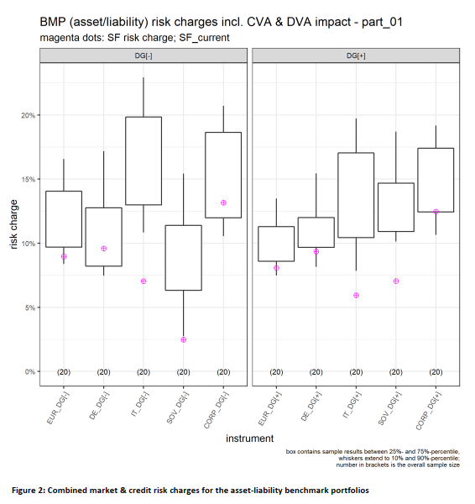

Note that DG [-] is related to the negative mismatch exposure, and DG[+] is related to the positive one.

THE IMPACT OF THE VOLATILITY ADJUSTMENT

About the volatility adjustment, it applies to the risk-free interest rate curve under Solvency II. It is based on a formula that takes into account the average credit spread on reference portfolios of fixed-income instruments and on the currency of the liabilities, by EIOPA.

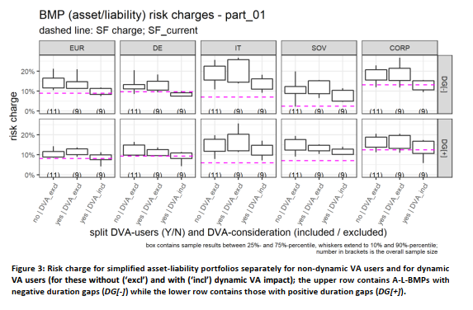

The figure 3 explain the differences between the non-dynamic VA users and dynamic VA users, of whom there are some which use a dynamic VA impact, compared to some BMPs (eur, de, it, sov, corp). On the top we recognise the DG[-], on the bottom the DG[+] is applied.

Note that VA users are 12 out of 20 (which means 8 of the insurance companies do not use the volatility adjustment, neither in a dynamic way nor in a non-dynamic way, but using the dynamic VA impact).

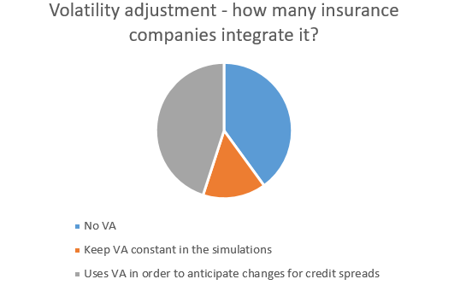

At the end, let’s talk about the figure 4, about the risk charges for different asset-BMPs.

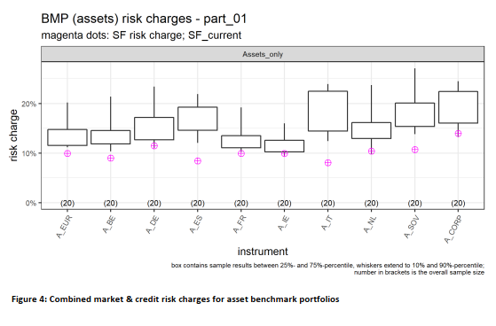

In this case, the benchmark portfolio shows a slightly higher volatility, that is the dispersion, in the case of the Italian benchmark.

We have already seen before (see the asset-liability-BMPs) an higher dispersion for the Italian case, anyway, and we saw that this is given to the fact that those benchmarks tends to hold a dominant weight of sovereign bonds (especially for the case of the sovereign bonds and Italian benchmarks).

In order to understand in a better way the interest rate ‘’down’’ movements, in the paper EIOPA chose to take into account other 2 BMPLs, that are combinations of different maturities and different portfolio durations.

# Francesco paolucci IBCM project: allianz



The interest risk in the analyses of the internal models doesn’t comprise two scenarios, in which the interest rate goes up or down, but a large amount of scenarios and simulations. The model regarding interest risk allow different hypothesis: the first one is a negative level of interest rates and the shocks to such level of interest.

In this case, one of the most important outcome from the analysis of the behaviour of operators is that there is a negative correlation between the duration of maturity, in fact the longer is the maturity the fewer participants to the study has a relevant exposure to these titles.

For a better compression of these aspects, the study analyses two different portfolio made up of short positions in risk free bonds. The results of the comparative study about these portfolios states that The portfolio with the longer duration exhibits higher risk charges as well as a larger dispersion, which is primarily driven by the fact that from a fixed income valuation perspective a higher duration implies higher absolute value changes and therefore variations at longer maturities are amplified.

Another important part of the study regards the evaluation of sovereign bonds, one of the commonest item of the benchmark portfolio.

In particular, as a preliminary condition we need to say that the value of a sovereign bond is determined by fluctuations in the interest rate level.

For the aim of the study bonds have been divided into three different groups: financial, non-financial and supranational. From the results of the study it is possible to show that Comparing across the groups of modelling approaches, credit risk charges at an instrument level were generally higher for those firms using an integrated approach (‘case A’, covering all facets of credit risk in an integrated simulation) versus those using a modular approach (‘non-case A’, for which only credit spread risk can be analysed at an instrument level).

Credit risk charges were also generally higher for bonds with lower credit ratings.

Comparing 5y bonds and 10y bonds is possible to observe that for firms using a modular approach spread shock is similar for the two type of bonds. While For firms with an integrated modelling approach, for which all facets of credit risk were analysed, modelled credit spread shocks were, on average, lower for 10Y bonds than for 5Y bonds. The difference was seen to become larger as the credit rating declined, especially for those attributed to the financial sector.

Regarding the rating the most important outcome reached by the study is that the dispersion of the lower rated bonds is higher than the highest rated bonds. In fact the study shows a greater dispersion for the bonds of low rated country like Italy or Spain than bonds from high rated countries. Analysis based on different approach for this topic shows that Three integrated models and one modular approach show a near-zero risk charge for all sovereign instruments. Another participant shows a near-zero risk charge for the German sovereign instrument.

Another part of the study shows that the study indicates that internal model firms apply a wider variation of risk charges for property risks when compared to listed equity risks. In contrast, risk charges for undertakings’ insurance participations exhibit significant dispersion. The study also indicates that the undertakings’ listed equity and property risk exposure tends to be in line with the standard formula shock. Further, for most undertakings, equity risk modelling is more sophisticated when compared to the property risk modelling. In particular for equity risk, the study shows that a smaller dispersion for the most important indices like SP 500 or FTSE 100.

The data request also comprised four standardised derivative instruments: one 5 year at-the-money European equity put (EuroStoxx 50) and three European at-the-money EUR-receiver swaptions with term-/tenor-combinations of 1/10, 10/10 and 20/20 years.

5 participants assigned an exposure relevance score of 2 or higher (immaterial to high) to the European equity put and 8 respectively for each of the swaption instruments. From the point of view of ‘invested assets’ these exposures are of limited materiality compared to the other asset classes and they are therefore not included in the benchmark portfolios (although it should be noted that equity put options are a common instrument for hedging the downside risk of equity exposures on an undertaking’s balance sheet). However, the relevance of these instruments also needs to be assessed in the context of valuing the Technical Provisions of the traditional life business, in particular their embedded options and guarantees.

The valuation of derivatives depends on several variables entering simultaneously in the pricing functions. Some of them have already been covered in other sections of this report (cf. sections 5.2.1 and 5.2.4) and therefore the following results are not based on ‘risk charges’. Instead, the focus is on the dynamics of the ‘implied volatility’ risk factor over a one-year horizon in the internal models.

the other part of the analysis involved drilling down to the level of single instruments. To close the ‘gap’ between these levels, the MCRCS includes an analysis of dependency structures within market risk, i.e. excluding migration and default of credit risk (technically speaking this refers to the part-02b data of the MCRCS questionnaire) and the dynamic volatility adjustment

it was then possible to construct bivariate Joint Quantile Exceedance probability (JQE) as the joint probability that both risk factors will simultaneously surpass the same quantile. For this exercise, a quantile of 80% was used on the one hand to allow for enough data to have significance and on the other hand to focus on the tail of the distribution. This estimator is a more relevant measure of tail dependencies than correlations, which take the whole distribution into account.

In the case of perfect negative dependence, we observe that the JQE equals zero. Indeed, a strong upward movement for one risk factor would be accompanied by an equally strong downward movement for the other risk factor.

The Market and Credit Risk Comparative Study (MCRCS) is not a stand-alone exercise but one important element in the EEA-supervisory tool-kit for monitoring the on-going appropriateness of internal market and credit risk models. Parts of it have been and are being used in other supervisory processes and especially the assessment of model changes and initial applications.

EXAMPLE OF A BENCHMARK PORTFOLIO

# Christian Polimeni IBCM project: Allianz

# 

INTERNAL CONTROL SYSTEM  
Allianz Group has an internal control system that incorporates entity-level controls (ELCA) and an integrated Risk and control System (IRCS) at the process level. These controls cover all elements of the governance system and operational activities, subject to constant reviews. Allianz Group employs a Three Lines of Defense Model for its internal control framework. The First Line of Defense, integrated into daily operations, involves management and risk activities. The Second Line, comprising Risk Management, Actuarial, Legal, and Compliance, independently monitors risk assumption and control activities, with special rights. The Third Line, conducted by Internal Audit, provides independent assurance by assessing the effectiveness of the Internal Control System In terms of organizational structure, Group Audit is the Internal Audit function for Allianz SE . The distinction between the lines is based on control activities, with each having independent control responsibilities. Allianz Group ensures the effectiveness of its Internal Control System through cooperation and information exchange among functions. The frequency and sequence of the audits over the course of a five-year audit cycle is determined using a risk-based approach, assigning risk ratings to all areas and topics in the audit universe. The resulting annual audit plan is approved by the Chairperson of the Board of Management and the Audit Committee. Subsequently, the Internal Audit function monitors the implementation of the auditee’s plans to remediate the identified deficiencies. Members of the Internal Audit function must avoid conflicts of interest in fact or appearance. The Actuarial function establishes fundamental principles concerning key responsibilities, organizational structure, and reporting and monitoring duties within the regulatory Actuarial function under the framework of Solvency II. Reporting directly to the Board of Management, the Group Actuarial function plays a crucial role in coordinating and validating the calculation of technical provisions for both Solvency II market value balance sheet and IFRS balance sheet. Additionally, it provides insights into underwriting and reinsurance strategy and actively contributes to risk management. Furthermore, the Group Actuarial function actively participates in implementing an effective risk management system, particularly through its involvement in the Group Finance and Risk Committee, overseeing the risk management framework of the entire Allianz Group. The Compliance function is a crucial element of the Allianz Group’s Internal Control System, overseen by the compliance department of Allianz SE, known as Group Compliance. Compliance collaborates with the Legal function to interpret and adhere to Solvency II regulations. It manages compliance activities through group-wide policies and a comprehensive organizational structure. Group Compliance monitors changes in the legal environment, receives reports from Allianz Group companies, advises and trains management and employees on compliance risk areas, and provides a speak-up facility for anonymous reporting of potentially unlawful behavior.

Risk part

The risk profile of the Allianz Group emphasizes a concentration in financial risks, particularly market and credit risks, arising from investments of premiums received to support insurance contracts. As of December 31, 2021, the Group's diversified risk capital increased by € 255,694. The rise in the Solvency II Capital Requirement is primarily attributable to the net effect of management actions. The Allianz Group employs a comprehensive stress-testing framework to manage its risk profile, consisting of various elements:

1. Parametric Stresses: These involve standardized shocks on single or multiple risk factors, impacting both Own Funds and risk capital. Examples include equity sensitivities, interest rate sensitivities, and combined sensitivities involving shocks on multiple market factors.

2. Historic Stresses: Simulating market movements observed during specific stress periods, such as the 2008 financial crisis, along with their respective impacts on capitalization.

3. Reverse Stress Tests: Identifying the severity level of a specific stress needed to meet a certain capitalization ratio. The Reverse Stress Tests analyzes how much financial stress or adverse situations the company can endure without excessively compromising its capital-to-risk ratio. This type of test is valuable for evaluating the financial robustness and resilience of an organization under adverse conditions.

4. Monthly Ad-Hoc Scenarios or Event-Driven Scenarios: Assessing the impact of current developments and potential upcoming events.

The sensitivity analyses presented are based on defined variations of specific parameters, describing the resulting capitalization development under idealized scenarios.

The Allianz Group adheres to the prudent person principle in its investments, ensuring the overall quality, security, liquidity, profitability, and availability of the portfolio in line with insurance obligations. Investments are made after careful identification, measurement, monitoring, and consideration of risks, as well as the interests of beneficiaries. Diversification is a key strategy, taking into account factors such as regions, risk categories, and subcategories. Correlation assumptions are derived from historical data or established by experts, using a Gaussian copula for risk dependency.

Market risk

The insurance company collects premiums from policyholders and invests in various assets, using derivatives to manage market risks. Asset/liability management (ALM) decisions rely on an internal model considering both risks and returns in the financial market. Exposure includes risks related to interest rates, stocks, credit spreads, inflation, implied volatilities, and currencies, especially focusing on long-term liabilities. Risk measurement involves real-world stochastic models, generating future scenarios for Value at Risk (Var) assessment. Risk management includes strategic asset allocation benchmarks, risk limits, and standards for hedging activities. Mitigation measures involve optimizing the portfolio through transactional, structural, and operational levers. Attention is given to risk concentration, addressing risks in equity, interest rates, credit spreads, inflation, currencies, and real estate.

CREDIT RISK

The credit risk arises from its investment portfolio, credit insurance activities, and external reinsurance. The investment portfolio comprises fixed-income bonds, loans, derivatives, and receivables, with potential losses tied to the credit quality of the obligors. Credit insurance involves potential claim payments due to credit risk associated with short-term trade credits. Reinsurance introduces credit risk linked to the non-recoverability or default of benefits. Credit risk is measured through an internal model considering exposure at default, rating, seniority, collateral, and maturity. Processes monitor exposure concentrations and limit utilization. Risk mitigation techniques include collateralization and careful selection of reinsurance partners.

LIQUIDITY RISK

The liquidity risk for the Allianz Group is the potential inability to meet current or future payment obligations, particularly in cases of timing discrepancies between cash inflows and outflows. This risk is managed locally within each legal entity of the group through active/passive management systems. Focusing on quality investments and maintaining liquid assets.

Liquidity planning involves reconciling sources such as investments and premiums with needs like insurance claims and expenses across various scenarios. The concentration of liquidity risks is managed locally, with various internal and external liquidity sources to mitigate shocks. Mitigation measures are in place, and in the event of limit breaches, escalation levels involve the intervention of the risk committee.

Quarterly liquidity risk reports, projecting cash flows, applying stress scenarios, and assessing countermeasures, are submitted by insurance legal entities. As of December 31, 2021, no limit breaches were observed. The expected profit included in future premiums amounted to €19,661,866 thousand.

OPERATIONAL RISK

Operational risks for the Allianz Group arise from inadequate or failed internal processes, human errors, system failures, and external events. These risks can originate from various sources, including "Clients, Products, and Business Practices," "Execution, Delivery, and Process Management," and other operational risks like internal or external fraud, financial misstatement risk, cyber security incidents, and potential disruptions from outsourcing partners.

The calculation of operational risk capital employs a scenario-based approach using expert judgment and internal/external operational loss data. Allianz has established a consistent operational risk management framework applied across the Group, emphasizing early recognition and proactive management of material operational risks. This framework defines roles, responsibilities, and management processes, with local risk managers identifying, evaluating, and reporting operational risks within their entities.

Operational risk concentrations are managed through the integrated risk and control system. Mitigation measures include specific control programs addressing compliance risks through written policies, financial misstatement risks through internal controls, and outsourcing risks through policies and business continuity programs. Cyber risks are mitigated through investments in cyber security, cyber insurance, and ongoing control activities.

Risk sensitivity, including estimates of frequency and severity of material operational risk events, is calculated based on scenarios used for internal model calibration.

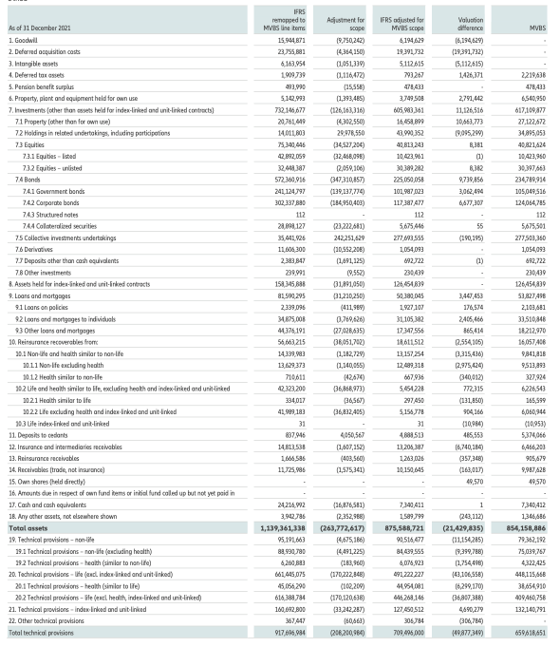

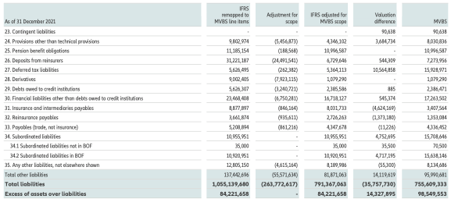

Analysis of Differences between IFRS and MVBS

1. Goodwill:

- Description: Intangible asset arising from business combinations, representing the economic value of assets not individually identifiable.

- Difference: Not recognized in MVBS, whereas recognized in IFRS consolidated financial statements.

2. Deferred Acquisition Costs:

- Description: Costs related to the acquisition and renewal of insurance and investment contracts with discretionary participation features, deferred when recoverable.

- Difference: Not recognized as a separate asset in MVBS, unlike in IFRS.

3. Intangible Assets:

- Description: Includes intangible assets other than goodwill, recognized in MVBS only if separable and evidence of exchange transactions exists.

- Difference: Recognized in IFRS but not in MVBS.

4. Deferred Tax Assets:

- Description: Amounts of income tax recoverable in future periods resulting from deductible temporary differences and tax credits.

- Difference: Calculated in MVBS based on temporary differences and revaluations, differing from IFRS.

5. Pension Benefit Surplus:

- Description: Net obligations related to employee pension schemes, valued in accordance with IAS 19.

- Difference: Consistency between IFRS and MVBS values.

6. Property, Plant, and Equipment Held for Own Use:

- Description: Includes tangible assets intended for permanent use, measured at fair value in MVBS.

- Difference: Measured at amortized cost in IFRS, whereas at fair value in MVBS.

7. Investments for Solvency II Purposes:

- Description: Investments are measured at fair value for Solvency II purposes, utilizing quoted prices in active markets when available. Market approach, cost approach, and income approach are alternative valuation methods employed when quoted prices are not accessible.

- Difference: Valuation methods align with IFRS 13, categorized into Level 1 (quoted prices), Level 2 (observable inputs), and Level 3 (non-market observable inputs). The Allianz Group prioritizes observable inputs and uses amortized cost as a proxy when fair value can't be reliably measured.

8. Equities:

- Description: Includes listed and unlisted equities, representing ownership in corporations. Excludes fully consolidated investees, joint ventures under IFRS 11, and associates under IAS 28.

- Difference: Fair value determined primarily by market prices; net asset value or income approach used when no quoted prices exist. Consistency in values between IFRS and MVBS, with no material differences.

9. Bonds and Collateralized Securities:

- Description: Encompasses government and corporate bonds, collateralized securities, including ABS and MBS. All financial assets under IAS 39 measured at fair value in MVBS.

- Difference: Fair value determined by market and income approach. Valuation distinction arises from bonds classified as "held to maturity" or "loans" measured at amortized cost in IFRS, while fair value is used in MVBS.

10. Investment Funds:

- Description: Includes stock funds, debt funds, real estate funds, private equity funds, and associated investment funds. All financial assets under IAS 39 measured at fair value in MVBS.

- Difference: Fair value determined by market prices, net asset value, or mark-to-model approaches. No material difference between IFRS and MVBS values.

11. Derivatives:

- Description: Financial instruments with values linked to underlying asset price movements. All financial assets under IAS 39 measured at fair value in MVBS.

- Difference: Fair value primarily determined by the income approach using present value techniques and the Black-Scholes-Merton model. Values consistent between IFRS and MVBS.

12. Deposits other than Cash Equivalents:

- Description: Short-term investments excluding transferable deposits. Measured at nominal amounts, considered a good proxy for fair value.

- Difference: Virtually no difference between IFRS and MVBS values.

13. Other Investments:

- Description: Investments not covered by previous categories. All financial assets under IAS 39 measured at fair value in MVBS.

- Difference: Fair value determined by market prices or mark-to-model method. Values consistent between IFRS and MVBS.

14. Assets held for Index-linked and Unit-linked Contracts:

- Description: Assets held for insurance or investment products where policyholders bear investment risk. Measured at fair value.

- Difference: No difference between IFRS and MVBS values; both measure assets at fair value.

15. Loans and Mortgages:

- Description: Grouped into three categories: loans to individuals, other loans, and loans on policies. Fair value derived using the income approach.

- Difference: IFRS measures these at amortized cost (IAS 39) while MVBS uses fair value, leading to valuation differences.

16. Reinsurance Recoverables:

- Difference: Valuation basis differences between IFRS and MVBS, further detailed in section "D.2 Technical Provisions."

17. Deposits to Cedants:

- Description: Deposits related to reinsurance accepted. Measured at fair value primarily using the income approach.

- Difference: Valuation basis differences; IFRS records at face value, while MVBS uses fair value.

18. Insurance and Intermediaries Receivables

- Difference: Recognizes certain premiums differently, included in receivables under IFRS but within technical provisions in MVBS.

19. Reinsurance Receivables

- Difference: Recognition of certain premiums differs, included in receivables under IFRS, within technical provisions in MVBS.

20. Receivables (Trade, Not Insurance

- Difference: Nominal value with an adjustment for probability of default used in both IFRS and MVBS, with market value in MVBS if it deviates materially.

21. Own Shares (Held Directly):

- Difference: IFRS deducts own shares from shareholders' equity; MVBS discloses as an asset, measured at market price.

22. Cash and Cash Equivalents:

- Difference: Virtually no difference between IFRS and MVBS values, both measured at nominal amounts.

# Robert roman IBCM project: Allianz



**D. 2 TECHNICAL PROVISIONS**

The Allianz Group requires technical provisions for its companies to be calculated according to Articles 76 and 77 of the Directive 2009/138/EC, in order for technical provisions to be disclosed as part of the MVBS.

Technical provisions correspond to the current amount that Allianz would have to pay if it immediately transferred its (re)insurance obligations to another (re)insurance undertaking. Technical provisions are calculated as the sum of best estimate liabilities (BEL) plus a risk margin (RM), which are determined separately.

The matching adjustment to the relevant risk-free interest rate term structure according to Article 77b and the transitional measures on risk-free interest rates referred to in Article 308c of the Directive 2009/138/EC are not applied, whereas the volatility adjustment according to Article 77d of the Directive 2009/138/EC is used.

Transitional measures referred to in the respective Article 308d were applied for the first time in 2020.

**D.2.1.3 Valuation differences between IFRS and MVBS**

The Allianz Group applies U.S. GAAP within the scope of IFRS 4(Phase I) for insurance contracts.

Although the definitions of “best estimate” provided under U.S. GAAP/IFRS and Solvency II are not identical, the theoretical concepts and calculation methods applied in the estimation process are the same, as is the judgment used in model selection and calibration. Consequently, under both regimes there is only one “company’s best estimate” for all LoB, which takes into account quantitative as well as qualitative information.

Acquisition costs under IFRS are deferred (deferred acquisition costs, DAC), while under Solvency II they are recognized when paid. In order to obtain comparable figures for “true” liabilities, DAC are deducted from IFRS reserves. As a breakdown of DAC by Solvency II LoB is not available, the adjustment is made at an aggregated level.

The main differences (between IFRS and MVBS) are:

* Different consideration of risk
* Different valuation basis
* Transitional deduction and volatility adjustment
* Interest rates
* Mapping differences

**D.2.2 Calculation of technical provisions**

**Proportionality**

The Actuarial function ensures that technical provisions are determined appropriately, using data, assumptions, and methods proportionate to the risk profile of the legal entity, taking into account the nature, scale, and complexity of the risks in question.

**Materiality**

The concept of materiality is an essential element in the calculation of technical provisions. It is reflected in the Allianz Group’s materiality concept for technical provisions, which applies to the scope, valuation method, assumptions, and data quality. The materiality concept is used in model governance to ensure that actuarial models are appropriate for the calculation of technical provisions.

**Expert judgment**

In line with the above, the valuation of technical provisions for all LoB is a process that requires expert judgment in a number of areas – for example, regarding the credibility assigned to historical data, the extent to which prospective models can be relied on, and the appropriate extent to which uncertainty must be considered in an estimation. Regardless of the technique, judgment is required in making additions or adjustments to estimates in order to allow for circumstances until now not included and which need to be incorporated in the BEL (best estimate liabilities) – for example, binary events. Hence, expert judgment cannot be regarded separately from all other tasks performed by the Actuarial function. Rather, its role is to complement the statistical analysis performed, interpret the results obtained, and identify a solution in the event of any shortcomings.

As part of the analysis, the Actuarial function substantiates the appropriateness of the expert judgment, in order to avoid biased estimates that over- or underestimate the true underlying risk. That said, expert judgment is not applied in isolation unless there is no reliable alternative, for example because there is a lack of relevant data. Where an assumption depends on expert judgment, it is expressed by person(s) with relevant knowledge and a comprehensive understanding of the subject.

The internal governance framework, which is set up by the Group, requires documentation on the expert judgment applied. The selection of the level and scope of documentation considers proportionality and materiality based on quantitative and qualitative indicators.

**D.2.2.5 Methods and assumptions used for valuation**

**Economic assumptions**

According to EIOPA guidelines, risk-free discount rates are used to discount future best-estimate cash flows. Wherever possible, the reference rate is the swap yield curve appropriate to the currency of the cash flows plus a volatility adjustment when applicable. In exceptional circumstances – i.e., if the swap market is not sufficiently deep or liquid and only government bond prices can be considered to fulfill liquid-market dynamics – the risk-free rates are based on government rates.

For the Life segment, Allianz uses a market-consistent valuation methodology based on risk-neutral economic models to derive the economic value of liabilities. In order to project future cash flows for the technical provisions, assumptions have to be made on the asset performance of the company. This requires consideration of the development of the capital market, together with assumptions on the company’s investment strategy, as well as the current asset portfolio and allocation.

Inflation is considered for the valuation of technical provisions, and the risk arising from changing inflation rates is subject to a regular monitoring.

**Transitional measures on technical provisions**

Insurance and reinsurance undertakings may, subject to prior approval by their supervisory authority, apply transitional measures on technical provisions in accordance with Article 308d of the Directive 2009/138/EC. Transitional measures on technical provisions are based on the difference between the Solvency II technical provisions and the value of the liabilities based on previous regulations. The maximum portion deductible shall decrease linearly at the end of each year from 100% during the year starting from 1 January 2016 to 0% on 1 January 2032.**Volatility adjustment (like my colleagues have explained at the beginning)**

EIOPA permits applying a volatility adjustment for the unintended consequences of short-term volatility of capital requirements. The volatility adjustment is a function of the market yield spread from a weighted average portfolio of sovereign and corporate bonds over risk-free rate. It is based on a reference portfolio per currency and per country. The risk-adjusted currency spread is applied as an adjustment to the discount rate. An additional adjustment is added to the discount rate, if the risk-adjusted country spread is significantly higher than the risk-adjusted currency spread.

For Non-Life business, the volatility adjustment was used for legal entities where the local regulator approved the application.

For Life business, the volatility adjustment was applied to all businesses, except variable annuities.

**Non-economic assumptions**

Non-economic assumptions such as mortality, morbidity, lapse rates, and expenses are determined by the respective business units, based on their best estimates as at the valuation date. Best estimate assumptions are set by considering past, current and expected future experience.

For Life business, future expected changes are taken into account in best-estimate assumptions only when sufficient evidence exists and the changes are reasonably certain. The crediting assumption considers future bonus rates reflecting either the management’s bonus philosophy, where bonuses are discretionary, or the policy conditions if the bonus policy is specified there. This is consistent with the future assumptions set for investment returns and any distribution of unallocated accrued surplus.

**D.3 OTHER LIABILITIES**

The classes of other liabilities described are the same as used in the MVBS. The aggregation is based on the nature and function of the liabilities and their materiality for solvency purposes. Unless stated otherwise, only valuation differences between “IFRS adjusted for MVBS scope” and “MVBS” values are discussed in this section.

* Contingent liabilities
* Provisions other than technical provisions
* Pension benefit obligations:

- Defined benefit plans

- Defined contribution plans

* Deposits from reinsurers
* Deferred tax liabilities
* Derivatives
* Debts owed to credit institutions
* Financial liabilities other than debts owed to credit institutions
* Insurance and intermediaries payables
* Payables (trade, not insurance)
* Subordinated liabilities
* Any other liabilities

**D.3.14 Leasing**

There is generally no valuation difference for other leasing assets and the finance lease obligation between MVBS and IFRS. The usual leasing assets – property, plant and equipment or lease receivables –are included in the respective balance sheet line items. Please refer to the respective valuation sections for those assets.

**Allianz Group as lessee**

**Allianz Group as lessor**

* Finance lease
* Operating lease

**D.5.1 Calculation of the credit spreads used for the valuation of financial liabilities**

In the internal model, the credit spread curves used for valuation and risk purposes are derived from fitted yield curves based on benchmark bond portfolios by using an industry-standard Nelson-Siegel model.

The credit spread curves are calculated as the difference of the credit yield curve (for example, government bonds) and the base curve, which is the EIOPA risk-free rate curve.

## Elie Ghazzoul

## IBCM Project: Allianz



E.1 OWN FUNDS:

The Allianz Group’s eligible Own Funds are composed of eligible Own Funds relating to the group of internal model and standard model entities, the sectorial Own Funds of credit institutions, investment firms and financial institutions, alternative investment fund managers and UCITS1 management companies as well as institutions for occupational retirement provisions, and the equivalent Own Funds of entities included via the deduction and aggregation (D&A) method.

E.1.4 Reconciliation between IFRS and MVBS excess of assets over liabilities:

The difference between MVBS (market value balance sheet) and IFRS (international financial reporting standards) excess assets over liabilities was attributable to many factors:

* IFRS balance sheet items not recognized in the MVBS (e.g., goodwill) and MVBS balance sheet items not recognized in IFRS (e.g., risk margin),
* Revaluation to fair value of assets and liabilities that are valued at amortized cost under IFRS (such as real estate and loans),
* Differences in disclosure and valuation of subordinated liabilities, differences in recognition and valuation of technical provisions and reinsurance recoverable, including the application of transitional measures for technical provisions,
* Participations
* Deferred taxes on the balance sheet differences given above.

**Reconciliation between IFRS and MVBS excess of assets over liabilities**

|  |  |
| --- | --- |
|  | |
| **IFRS excess of assets over liabilities** | **84,221,658** |
| (1) Goodwill and intangible assets | (11,307,245) |
| Deferred acquisition costs | (19,391,732) |
| Risk margin | (7,211,085) |
| (2) Property (before PHP and tax) | 13,455,215 |
|  |  |
| Bonds | 9,739,856 |
| Loans and mortgages (before PHP and tax) | 3,447,453 |
| (3) Subordinated liabilities1 | (4,752,695) |
| (4) Technical provisions net of reinsurance recoverable | 54,534,330 |
| (5) Participations | (9,095,299) |
| (6) Deferred taxes | (9,138,487) |
| Other | (5,952,416) |
| **MVBS excess of assets over liabilities** | **98,549,553** |
|  | |
| . | |

E.2 SOLVENCY CAPITAL REQUIREMENT AND MINIMUM CAPITAL REQUIREMENT

Solvency II Capital Requirement (SCR), for entities that use the standard formula to determine their Solo SCRs, standard formula results are used for the aggregation of the Group Solvency II Capital Requirement. Simplifications are applied in the “counterparty default” risk module of the standard formula calculations. The increase in the SCR was mainly due to management actions (acquisitions businesses in Poland, Australia and Italy).

E.4 DIFFERENCES BETWEEN THE STANDARD FORMULA AND ANY INTERNAL MODEL USED:

The internal model is at the core of the risk management framework. The internal model is based on a Value at Risk (VaR) approach using the Monte Carlo simulation. Risk calculation begins with the market value balance sheet, attributing each asset and liability position to relevant risk drivers and associated risk categories. A bond’s value, for example, will be impacted by the respective risk-free interest rate curve and credit spread curve (amongst other things). As a result, it will be covered by the respective market risk categories, such as interest rate, credit-spread or currency risk, as well as the credit risk category. Wherever possible, distributions are calibrated to market data or our own internal historical data, for example, in setting actuarial assumptions. In addition, we consider recommendations from the insurance industry, supervisory authorities, and actuarial associations.

**For the valuation of technical provisions**, a volatility adjustment (VA) is applied on top of the risk-free interest rate curve. Therefore, the internal model contains a dynamic component to cover this impact. Allianz’s approach to model the dynamic component differs methodologically from the static EIOPA VA concept applied in the standard formula. In our risk capital calculations, we reflect the impact of the dynamic movement of the VA based on the credit spread movements of our own portfolio. This asset-sided effect is transferred to the liability side by using asset and liability durations. To account for deviations with respect to the EIOPA VA methodology, Allianz applies a more conservative, reduced application ratio for the dynamic volatility adjustment. A regular validation is performed to verify the appropriateness and prudency of the approach.

Allianz performs several stress tests for market risks (also known as parametric stresses and discussed previously), as well as for underwriting risks, on both a regular and an ad-hoc basis.  
The shocks on underwriting risks are simulated by identifying one- in-ten-year non-market risk events and calculating their corresponding impact.

The following two figures show the risk categories contained in the internal model and, for the sake of comparison, the structure of the standard formula.

**Structure of the internal model**

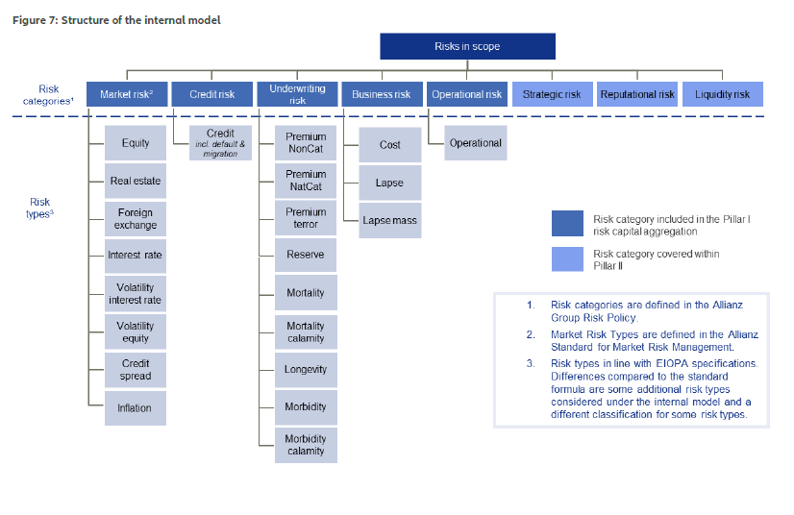

Structure of the standard formula

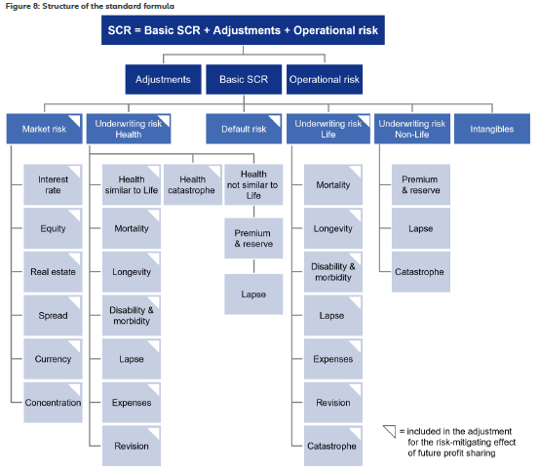

**For the aggregation of risks**, we use an industry-standard approach based on Gaussian copulas. A correlation matrix defines the interdependencies between the risks modeled by the copula. Wherever possible, we derive correlation parameters for each pair of market risks through statistical analyses of historical data, considering observations over more than a decade.  
This is done by a dedicated internal committee – the Correlation Setting Committee – which combines the expertise of risk and business experts. The correlations are generally set to reflect the dependency between the full distributions of the factors the correlation refers to. The correlations describing the dependency between the full distributions are increased by a factor in case a particularly strong dependence in the tails (i.e., in extreme events) is assumed.

The internal model considers a correlation between all risk driver pairs modeled, while the standard formula considers intra- and inter-risk category correlations. Therefore, the diversification benefit in the internal model is larger than in the standard formula.

Additional capital requirements are taken into account for entities that are not included in the scope of the internal model. For insurance entities, these requirements are based on the standard formula. For entities considered according to third-country equivalence principles (mainly Allianz Life Insurance Company of North America), these requirements are based on the respective local capital requirements. Non-insurance entities are included according to their respective sectorial capital requirements, for example, banks or asset managers. These additional capital requirements of the entities that do not apply the internal model are aggregated to the Group Solvency II Capital Requirement based on a factor-based approach. The factor-based approach ensures that the diversification benefit to the Group is appropriately accounted for.

A fundamental difference between the standard formula and the internal model is that the standard formula uses factor-based shock scenarios, while the internal model derives the risk capital by simulating each risk driver (and its corresponding economic profit and loss impact) based on its assumed distribution and interdependence with other risk drivers.

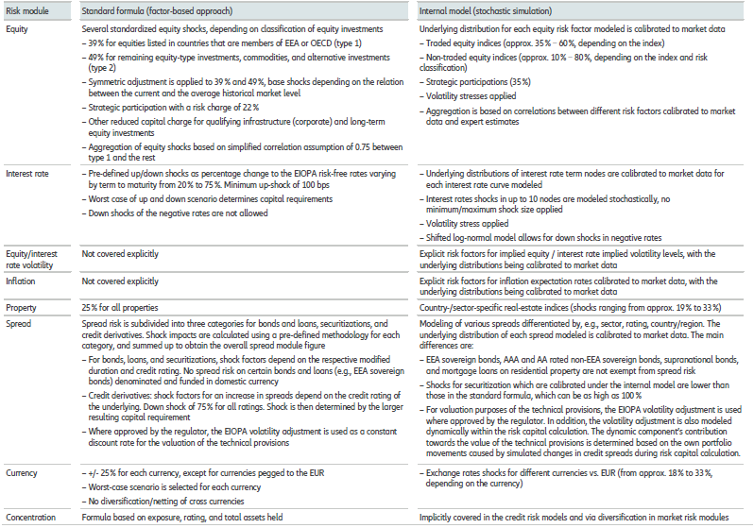

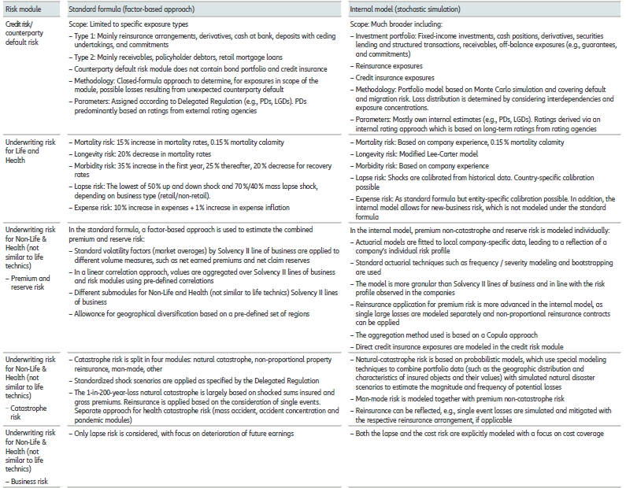  
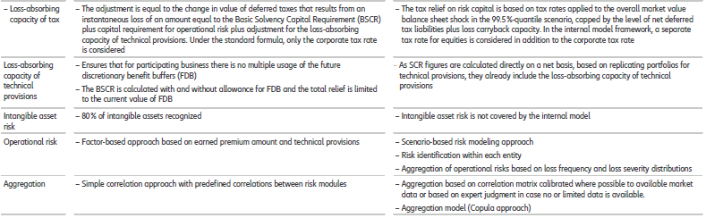

**For Non-Life underwriting risk,** there are only small differences in the risks covered by the internal model compared to the standard formula. The main differences between the internal model and the standard formula pertain to the modeling approach.  
**For Life/Health underwriting risk**, the covered risks deviate; the internal model covers both longevity risks for pension obligations for employees and a new-business shock for the expense risk, whereas neither of these risks are accounted for in the standard formula. **Another difference concerns the credit risk module**: In contrast to the standard formula, the internal credit risk module covers the entire bond and loan portfolio, as well as credit insurance exposures. This allows us to model diversification and concentration effects across all credit-risk-bearing exposures.

Model and scenario parameters derived from historical data are used to characterize future possible risk events. If future market conditions differ substantially from the past, for example in an unprecedented crisis, the VaR approach may be too conservative or too liberal in ways that are difficult to predict. Therefore, to mitigate reliance on historical data, we complement our VaR analysis with stress testing. The appropriateness of this data is verified regularly, both internally and by external auditors.

The market risk model uses inputs such as investment data and market data. The internal credit risk model uses investment and exposure data (for example, nominal values, market values and maturities), obligor and counterparty data (for example, ratings, sector, and country information), parameter data (for example, probabilities of default, loss-given-default, and correlation data), as well as market data (for example, interest rates and foreign exchange rates).

To ensure the appropriateness of the data used in the internal model, Allianz has established a control environment accompanied by internal guidelines, documented processes, and data checks. There is a regular model validation process to assess the underlying data and ensure it is appropriate for the calibration of the internal market and credit risk models.

In general, the internal model offers a higher diversification benefit, as it reflects the prevailing geographical diversification within a multinational Group, which is not adequately considered under the standard formula. This structural difference also affects the diversification within risk modules. In particular, the internal model accounts for diversification by country and sector within market risk sub-modules, something which is neglected in the standard formula calibration. Also, the diversification effects within market risk modules and sub-modules are deemed more appropriate given the long historical time series used for calibration including the 2008 – 2012 crisis scenarios. One prominent example of the impact of this difference would be lower credit spread risk capital in the internal model, in combination with the dynamic VA offset for credit spread risk, which is only permitted in the internal model. Therefore, the quantitative impact on the overall SCR based on the standard formula is generally higher than under the internal model.